Missouri Cattlemen’s Association
Buckle Order Form

Proceeds benefit the MCA Political Action Committee

Adult Buckle
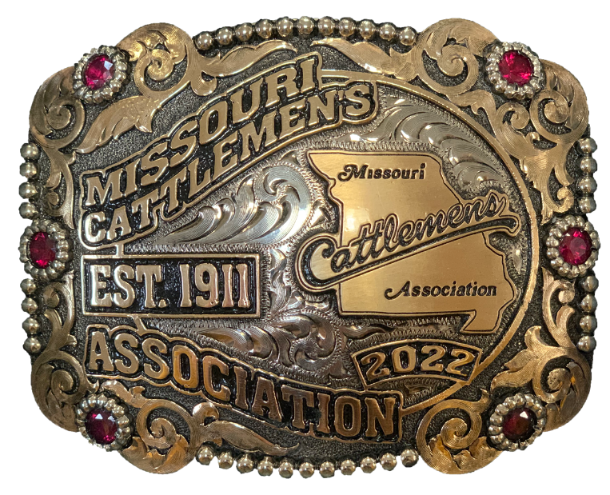

Name:________________________________________________________________________

Address: ______________________________________________________________________

City: _____________________________ State: ________ Zip: ___________________________

Number of Adult Buckles ($150/each): ______________________________________________

Order Total: ___________________________________________________________________

Pick Up/Shipping (Free Shipping): _________________________________________________ *Pick up will be at MCA Headquarters in Columbia, MO.

Payment Type: Check #: ___________________________________________ (check attached)
**All checks should be made payable to MCA PAC.

Card #: __________________________________ Exp: ___________ Security Code: __________

Please send completed form to
lisa@mocattle.com
or mail to MCA Headquarters:
2306 Bluff Creek Drive
Columbia, MO 65201

