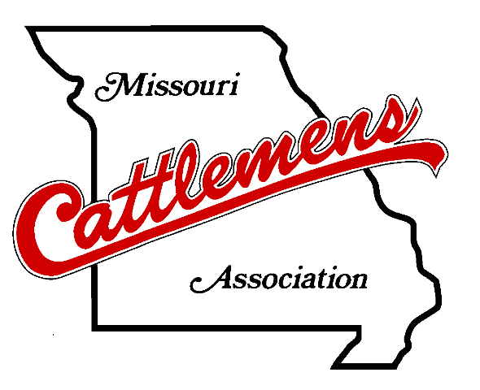
Missouri Cattlemen’s Association
2022 Awards for Excellence
Application

Affiliate:
Signature of Affiliate Representative:
Date Submitted:
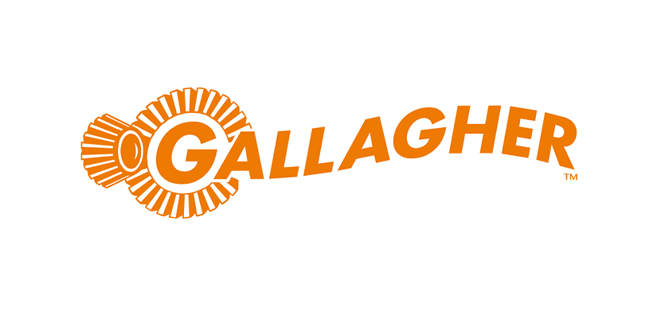
Sponsored By
Gallagher

The Awards for Excellence program is designed to reward affiliates for their activities and involvement in supporting the cattle industry in Missouri.

General Guidelines
- Entries must be submitted on the Awards for Excellence Application form.
- Entries must be postmarked by December 1, 2022 to qualify. Entries postmarked after that date will not be eligible for participation in the program.
- Points will be given for activities from October 1, 2021 to September 30, 2022.
- An event, activity or program may be counted only once.
- Only affiliate activities will be considered by judges.
- The affiliate association is responsible for keeping an accurate record of their activities (county, state & national) that are submitted in this award. The affiliate may be asked to show information regarding a specific activity.
- Please note: Please do not submit additional materials (scrapbooks, photo albums, etc.) with your application. Additional materials will not be judged. However, affiliate scrapbooks and albums may be brought to convention to be displayed at the MCA membership booth.

Awards for Excellence Categories
Overall Affiliate
Overall Affiliate Runner Up
Outstanding Affiliate Activity/Event
Outstanding Affiliate Beef Promotion
Outstanding Affiliate Policy Involvement

Please mail, email or fax application to:
Missouri Cattlemen's Association • 2306 Bluff Creek Drive • Columbia, MO 65201
Fax: (573) 499-9167 • lisa@mocattle.com

Awards for Excellence Focus
County affiliates are the heart of the Missouri Cattlemen's Association. The influence of the state association depends heavily on the strength of its affiliates. Therefore, the emphasis of this awards program will be focused on the affiliate’s involvement in the various areas of emphasis.

Affiliate Meetings
Membership, Board and Committee Meetings – Please list all meetings individually with date, description of meeting, speaker, and number in attendance.

Date | Meeting Description & Speaker, if applicable | Attendance

Affiliate Activities, Events & Programs
Be sure to list ALL activities and programs your affiliate participates in on the county level. Everything you do is worth consideration, even the smallest activities.
Please feel free to include additional pages with deeper descriptions of each event so they can receive appropriate consideration.

Activity | Description | Date | Attendance
Beef Promotion
Be sure to list ALL activities and programs your affiliate participates in on the county level that promote beef. Everything you do is worth consideration, even the smallest activities. This would include beef education in the classroom, Beef Month activities, educational seminars, etc.
Please feel free to include additional pages with deeper descriptions of each event so they can receive appropriate consideration.
Activity | Description | Date | Attendance

Legislative & Policy Involvement
Be sure to list ALL activities and programs your affiliate participates in. Everything you do is worth consideration, even the smallest activities. This would include participating in Cowboys at the Capitol, a candidate forum, county and state policy recommendations, etc.
Please feel free to include additional pages with deeper descriptions of each event so they can receive appropriate consideration.

Activity | Description | Date | Attendance

Affiliate Public Relations
Please list all stories, posts or articles submitted to print media, radio, television or social media, even if they were not used by the media source.
Subject | Month
State Participation
These activities and events are put on by the state association to promote the Missouri cattle industry.
Activity | Average Number of Attendees/Participants
Missouri Cattle Industry Convention & Trade Show
Missouri Cattlemen’s Leadership College
MCA Steak Fry
Cattlemen’s Classic Golf Tournament
Members Participating on State Committees (Convention, Beef House,
Policy, etc.)
MCA All-Breeds Junior Show
State Quarterly Board of Directors Meetings
Did your county donate any items to the live auction or
silent auction at convention?
Yes ____ No ____
If yes, please indicate number of items donated _____
Is your county represented on the MCA Brand Wall?
Yes ____ No ____

National Participation
Activities your affiliate organization has participated in or attended at the national level.
Activity | Date | Attendance

Office use only  This portion will be completed by the MCA Staff. |  | Date received:
Membership Statistics
Total members, FY2020 ________  Total members, FY2021 ________ |  | Renewal Percentage _____  New members, FY2022 ________
Total members, FY2022 ________ |  | NCBA members, FY2022 ________
Junior members, FY2022 _______

Beef House Volunteer Statistics
Beef House Volunteers Scheduled _____ |  | Beef House Volunteers Signed In _____
Beef House Volunteer Percentage _____

